THE ELITES WILL BE REPLACED

First, WHAT is the definition of an elite? According to Merriam Webster, the elite are a group of persons who by virtue of position or education exercise much power or influence. For the following discussion, the focus is on those in positions of power like government officials, central bankers and corporate CEOs.

Second, WHY do the elites act the way they do? If you listen only to their soothing and caring words, then you might think that philanthropy or doing the Lord’s work is their motivation. However, when you look at their actions (not words) and the facts surrounding each unique situation, you will likely find other sinister desires. Surely all human beings are motivated to help others, but when given absolute power to control people, the elites can regrettably drift from their moral and right compass. As the saying goes, absolute power corrupts absolutely. If other people are taken advantage of or sacrificed in order to promote the organization that the elite rules over, then those effects may be deemed inconsequential. The driving factor for why elites act is to promote and strengthen their own organization and self. Inevitably, two different elites will have conflicting agendas. Will you side with elite #1 or elite #2, or will you likely be caught in the middle as a sacrificial pawn in their chess game? You will very likely become one of the billions of sheeple slaves subject to the dangerous consequences if you do not choose your side carefully.

Third, WHERE can the elites be found? They can be found at institutions all over the world. In many instances, these institutions wield their power through deception, bribery or intimidation. So logically, we must look closely at the leaders of governments, central bankers, educators, media, corporations, private bankers, and military organizations around the world. These institutions will often collaborate and form alliances to advance a common agenda. For example, the educators/media/governments will advance misinformation or often an outright lie, then the bankers/corporations will financially influence an action, and finally a military alliance will physically silence any opposition to the group’s goals. Let’s hope that the recent meeting in Davos, Switzerland had truly philanthropic intentions.

Fourth, WHO are the elites?

- Government leaders (e.g. Presidents, Legislators, Dictators)
- Global central bankers (e.g. Federal Reserve, BIS, ECB, BOJ)
- Educators (e.g. policy makers, administrators, teachers that influence a child’s curriculum)
- Media (e.g. journalists, broadcasters, commentators that bias their reporting and intentionally leave out valuable information)
- Corporations (e.g. CEOs, Executive Boards)
- Commercial, Private and Investment Bankers (e.g. banks with fractional reserve requirements, specifically the too big too fail banks that have the most influence)
- Military (e.g. Defense Departments, National Guards, armies and militias)

These elites have performed amazing feats and demonstrated exceptional leadership throughout history. The great advancement in human progress and ingenuity over the last century has been largely due to their unselfish leadership. However, there have been very questionable (and often immoral) decisions in the early 21st century that will eventually bring great harm to so many people. I believe that in the very imminent future, the elites will have one last chance to make the moral and right decisions that the world so desperately needs. Look at the list above again, and hopefully you can appreciate the sheer magnitude of the power and influence of the elites. My references to their questionable (and often immoral) decisions are too many to discuss in this writing, but suffice it to say that the list includes recent lies and unilateral actions about wars, occupations, money printing, inflation, quantitative easing, direct market interventions, bailouts, deficit spending, peak oil, and global warming.

Fifth, HOW do the elites attempt to control and influence people? This answer is simple and was previously mentioned. The elites wield their power through deception, bribery or intimidation. Each of these methods of control will be discussed separately.

The deception of the sheeples is relatively easy and accounts for the confusion, distraction or empathy in the majority of the population. Starting with early childhood through our stubborn old age, we are deliberately “taught” half-truths, one-sided stories and red herrings. I am truly shocked that so many facts and other important information are deliberately left out of the conversation that the elites should no longer be trusted to provide this information. One does not have to look far to see these mistruths and red herrings on display in the educational institutions, media news coverage, or politician’s and central banker’s press statements. In today’s information era, there are so many enlightening websites and blogs to get the complete information and differing views. Although in some parts of the world, Internet censorship further obscures the truth. Educate quickly before full global censorship may be implemented. The following examples are just of few to demonstrate deceit.

- One requirement of money is to be a store of value. The history of fiat paper money should be enough evidence that fiat paper is not a store of value. Rather, gold has been true money for thousands of years.
- Prior to the shale oil extraction, two-thirds of the world’s oil supply was located in the “oil triangle” at the heart of the Middle East. Many have known Iraq as the “oil prize”. Annual global production decline rates average 5% per year, with shale oil wells typically greater than 50% annual decline rates. The past, current and future wars in the Middle East should be no surprise to anyone why they are occurring. The treasure of these wars is that precious fossil fuel gift from the heavens…..black gold…..oil.
- The Federal Reserve Bank’s recent and repeated dark money injections have been significant, and it is shocking that the recent hundreds of billions of dollars funneled into the repo market have been called “not-QE”. If fiat paper money and the resultant credit are injected into the system out of thin air, then it is quantitative easing with the same intent to desperately create money supply and inflation in the economy.
- The limits to debt accumulation have thresholds before the point of no return, which is a point that politicians conveniently ignore. The current debt levels around the world have likely crossed the point of no return, which will bring severe negative consequences as payments inevitably come due.
- We are told that stable prices are a Congressional mandate for the Federal Reserve Bank, yet college tuition, healthcare, housing and so many other necessary costs continue to skyrocket at near double-digit inflation rates.

The bribery of the sheeples is the next preferred method of control when deception is no longer effective. Perhaps the 10% to 20% intelligent portion of the population can then be bribed with an inflated salary, home price or 401(k) to ignore the remaining hidden truths. The classic example of bribery is what I call the Three-Headed Monster. The three heads of this monster are the monetary, fiscal and wealth effect. Each head surreptitiously creates additional money and credit in the entire economy, i.e. inflation. These operations are so stealthy that maybe one in a million will detect and understand. This bribery, much like the deceits, creates very unfortunate and often catastrophic consequences once this method is inevitably revealed to be temporary and unsustainable. There are economic and psychological limits to the monetary, fiscal and wealth effect modus operandi. Perhaps we are currently experiencing another disastrous asset bubble in the equity, debt and real estate markets. The following examples are just of few to demonstrate bribery.

- The US bailout of bankers, auto dealers and other failed corporations was the $700 Billion dollar Troubled Asset Relief Program (TARP) paid for by the taxpayers. So if I understand this right, the taxpayers paid for the bailout and then had to grovel on hand and knee back to these same bankers asking for a loan of their money back…. at 6% or more interest?
- President Trump’s tax cuts for the wealthy corporations added considerable debt, again at the taxpayer’s expense. The taxpayers will continue to pay interest on this borrowed money for decades to come, albeit stealthily.
- President Bush’s tax cuts for the average working family added considerable debt, again at the taxpayer’s expense. The taxpayers will continue to pay interest on this borrowed money for decades to come, albeit stealthily.
- The Federal Reserve’s recent and continuous interventions in the repo market are significant and benefitting the very few. People must ask what is truly going on and why, and ask who is really benefitting from these socialist interventions. If we are told that we all benefit and you believe that, then hope may truly be lost.

The intimidation of the sheeples is the final method of ultimate control over people, both domestically and internationally. The affected percentage of the population that requires this brutal treatment is probably in the 1% to 2% range. There are countless examples throughout history that can demonstrate this simple and crude tactic of enforcement. Intimidation may come in many forms. For example, the threat of imprisonment or other harm, economic sanctions, assassinations, initiation of war and occupation, verbal threats to whistleblowers, or even termination of employment. Very often with intimidation, the immorality becomes evident. Stories will be told about the “bad guy” and “boogieman” but if one looks deeper into the facts and complete information, the other side of the story can easily be learned. Intimidation and violence are so denounced in today’s society, yet the wars rage on almost undetected and apathetically with the masses. These wars and violence are disturbing and hopefully the elites will end the wars, occupations and assassinations before the Great Escalation, but it is probably too late to peacefully end the chaos in the Middle East. I suppose our Creator will be the ultimate judge, but the needless suffering of so many should be avoided as much as possible. Wars are inevitable, they have their time and place and are part of nature, but the ultimate contemplation is necessary before hastily making these life and death decisions. The following examples are just of few to demonstrate intimidation.

- War in Iraq (2003) based on false evidence. Iraq has super mega oil fields and is known as the oil prize in the industry. Also, Saddam Hussein required that Iraq’s oil be paid for in non-dollar denominated currencies.
- Assassination of Iranian General Soleimani (2020). Similar to Saddam Hussein, Iran was selling oil in non-dollar denominated currencies. Congress was not consulted prior to this attack. Similar to the war in Iraq, this assassination was decided by unconstitutional powers and without Congress’ approval. By definition, the power and influence of the elites is grossly evident.
- Imposing tariffs or economic sanctions are essentially acts of war. The recipient of these aggressions is supposed to be intimidated into compromise. As we will surely learn, not all goes according to the plan.

Sixth and final, WHEN will the elites make the right and moral choices necessary to strengthen the people of our great nation? As a child, adolescent and early adult, I trusted my elders and government leaders (a.k.a. elites) to always make the right and moral decisions. As I educated myself independently through adulthood, this trust in the elites has become questionable. The simplest of facts, truths or moral decisions always seems to be conveniently ignored by the elites and hidden from the masses. Instead, their twisted ideologies of more inflation, debt, war, socialism, currency debasement, red herrings and government interference in just about every aspect of personal life and financial markets continue advancing without pause. The elite’s recent performances are analogous to a heroin addict, always saying that everything will be ok after the next drug injection. The masses have finally woken up and realize that the elite’s next action will likely be another tragic mistake.

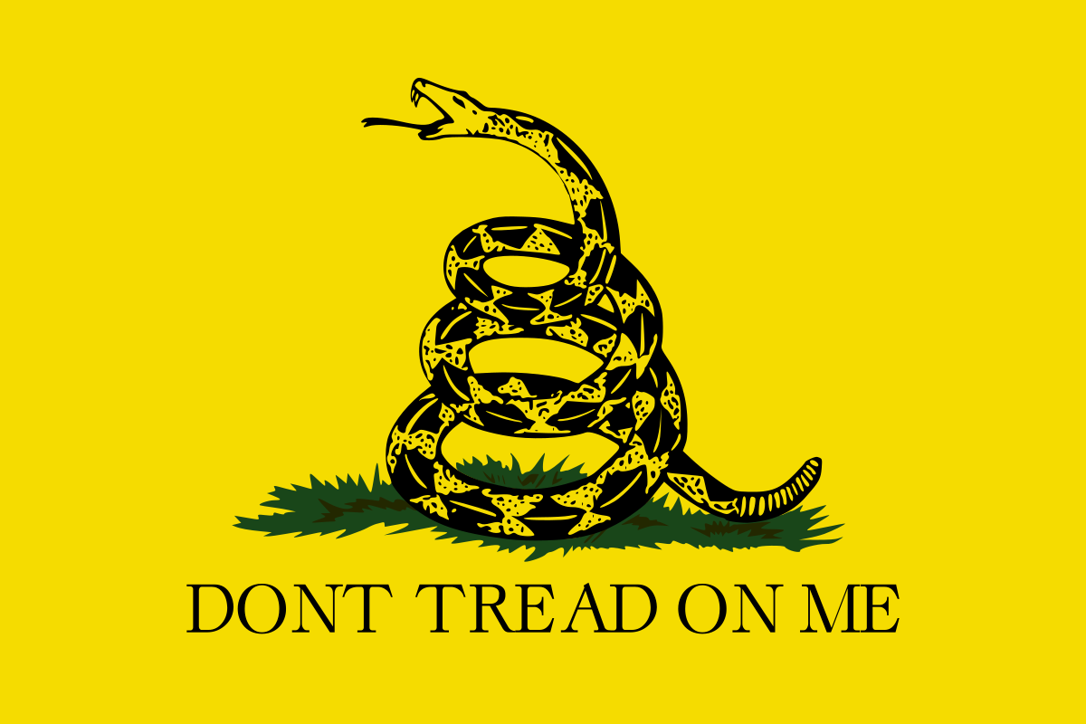

The time for an intervention is right now! The elites appear to be incapable of making the right decisions about money, peace, free markets, morality and simply telling the truth. The problem with a heroin addict is that the drug addiction becomes too much to overcome. The heroin use regrettably becomes “excessive”, “dishonest”, “irresponsible” and “chronic”. Eventually, the addict delivers that fatal dose. The necessary solution is to intervene early and immediately stop using heroin. When done in excess or for the wrong reasons, history proves that chronic mistakes with fiat currency, war, foreign occupation, socialism, energy supply (oil), excessive debt, asset bubbles, deficit spending, social class disintegration, or direct market interventions can quickly result in depression and collapse.

One must be asking at this point, what are the solutions that we expect the elites to implement? The simplicity of the solutions may come as a shock to many. Choose a vision of greatness and promise, and simultaneously stop the many bad policies that are causing irreparable harm. In one simple example, “I want to free myself out of this hole, so I must stop digging today!” For those that have tried to quit smoking, it is a hard habit to break. The optics of your vision should be that “I want to live to be 100 years old, so I must stop smoking today!” If our elites cannot make the difficult decisions necessary to save our future, then they should be immediately replaced. Do our current and past leaders really think that printing fiat green paper, initiating many wars, chronic deficit spending, corporate bailouts, direct interventions in financial markets, or denial of Peak Oil will “Make America Great Again”? The Green Paper Revolution is approaching faster then they would like to admit. Do not be deceived, bribed or intimidated any longer!

In conclusion, let’s consider the following vision statements, which all include the word “balance”. After all, there are two sides to every debate that must be delicately balanced. The reason that we have trusted the elites in the past is because of their thoughtful leadership that adequately “balanced” the benefits and risks of its constituents. Can they continue to demonstrate this balanced, fair and moral leadership?

- Our government leaders will balance fiscal budgets and personal liberties for all citizens.
- Do NOT continue massive deficit spending
- Do NOT continue interventions in financial markets and personal lives
- Do NOT continue to bail out the elites that are taking excessive risks

- Our central bankers will balance economic stability and currency value for all financial participants.
- Do NOT continue increasing the money supply and credit via unprecedented “quantitative easing” or repo market injections
- Do NOT continue manipulating interest rates towards zero (ZIRP) or negative (NIRP), which fuels a search for yield and inflates asset bubbles
- Do NOT continue creating the inflation that is destroying the lower and middle income classes

- Our educators will balance all-inclusive viewpoints and facts for all students.
- Do NOT continue teaching one-sided history lessons and current events
- Do NOT continue the omission of critical laws of nature, economics, war and so many others
- Do NOT continue the omission of life’s lessons about money, war, oil energy, entrepreneurship, business and psychology

- Our media will balance fairness and biases for all audiences.
- Do NOT continue presenting illogical arguments based on fantasy
- Do NOT continue deliberately offering red herrings when the “real” story is not told
- Do NOT continue advancing the agendas of elites that advocate war propaganda, expansion of financial bubbles or the oppression of unprovoked peoples

- Our corporations will balance sustainability and growth for all employees, customers and shareholders.
- Do NOT continue unsustainable borrowing or acquisitions that jeopardize the company’s future, e.g. zombie corporations or bankruptcies
- Do NOT continue inappropriate stock buybacks to artificially and temporarily boost earnings per share
- Do NOT continue making fairy tale forecasts about future growth, only to make hasty revisions after the predictable reality hits

- Our commercial, private and investment bankers will balance honesty and fair disclosure for all investors, savers and borrowers.
- Do NOT continue excessive leveraged risk taking, e.g. derivatives or leveraged debt
- Do NOT continue facilitating the “wealth effect” bubbles when asset prices have become excessively overvalued by historical norms
- Do NOT continue misleading investors with excessively biased “buy” recommendations

- Our military will balance morality and protection of human beings in disagreement.
- Do NOT continue the false justification of wars when the true “spoils of war” are obvious to the elites (but probably not obvious to the sheeples)
- Do NOT initiate aggression for unscrupulous reasons like controlling the oil supply, protecting petrodollars or stimulating economic growth
- Do NOT continue the expensive policing and oppression of so many countries around the world

